Absolution Build A Testing – Tom and Michael

Tell Navy what the most controversial story thing was too by the end of it

Use quick saves, or try to

Week 1 – Attempt 1 – Teal

So far nothing wrong with screens in the instructions.

Made it to 3 empathy with Sue, so hopefully that’s good enough.

During the interview I realize now that the green dialogue choices are the best, I think.

I think I caught a typo, the screen where she says “looking at me analytical” needs to be an adverb. I clicked through too quickly to see though.

Well shit, she left and it was pointed out I did the full tour sub-optimally. Interesting. I’m going to try a second attempt.

Attempt 2- Numbers and spaces can’t be added to the name so I’ll name her TwoTeal

Ask about eating in the cafeteria, thanks for the warning, patient time outside room, what do you like to do on breaks, OOH that’s a big difference. The savegame thumbnail has Sue in it now.

Interview attempt two. “I don’t celebrate [Halloween].” What a controversial take.

Day 1 ending will be saved at slot 6 page 1 (slot 6 page 5 for emergencies, if I lose it), hopefully that’s enough for me to work with.

~~Day 2 start~~ Day 1 start (didn’t realize the numbering system was this way, whoops)

Tutorial part 3 has a typo, paragraph 3, “proffessional” occurs twice, it only needs one F.

Starting with Michael, since choices don’t matter.

Michael day 1 typo after “’Scratching’ me?” Dialogue choice. “I shift in my seat...” Has the word “beetween” which should be “between.”

I’m saving at the start of Tom’s session for day 1 in case I can get a head start on affinity with him.

First choice, second prompt, advances. Second choice, third prompt advances.

Day 2

Tutorial part 5 has a typo, second paragraph before bullets. “Advized” should be “advised”

About to select Tom for the first route

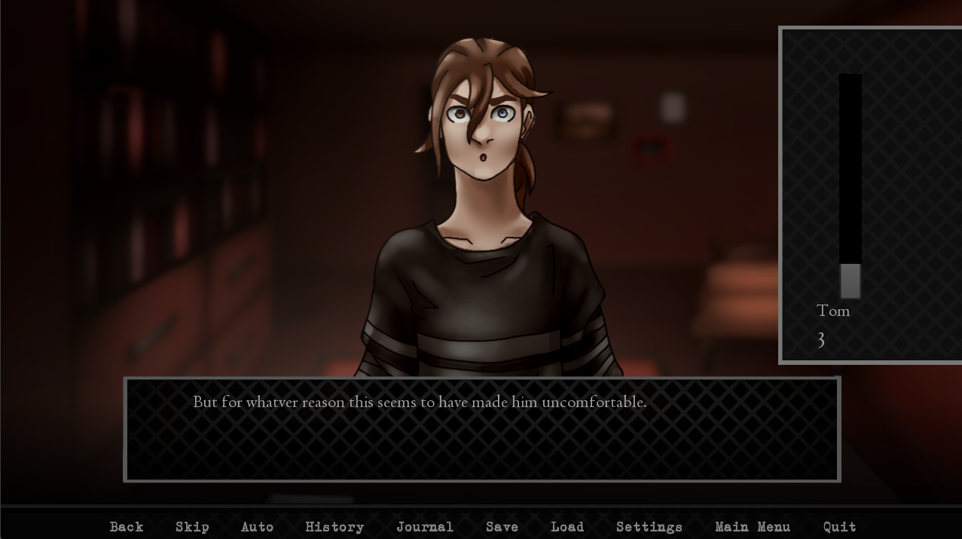

Typo on “whatver.” No problems so far. Exhausting dialogue choices as I go.

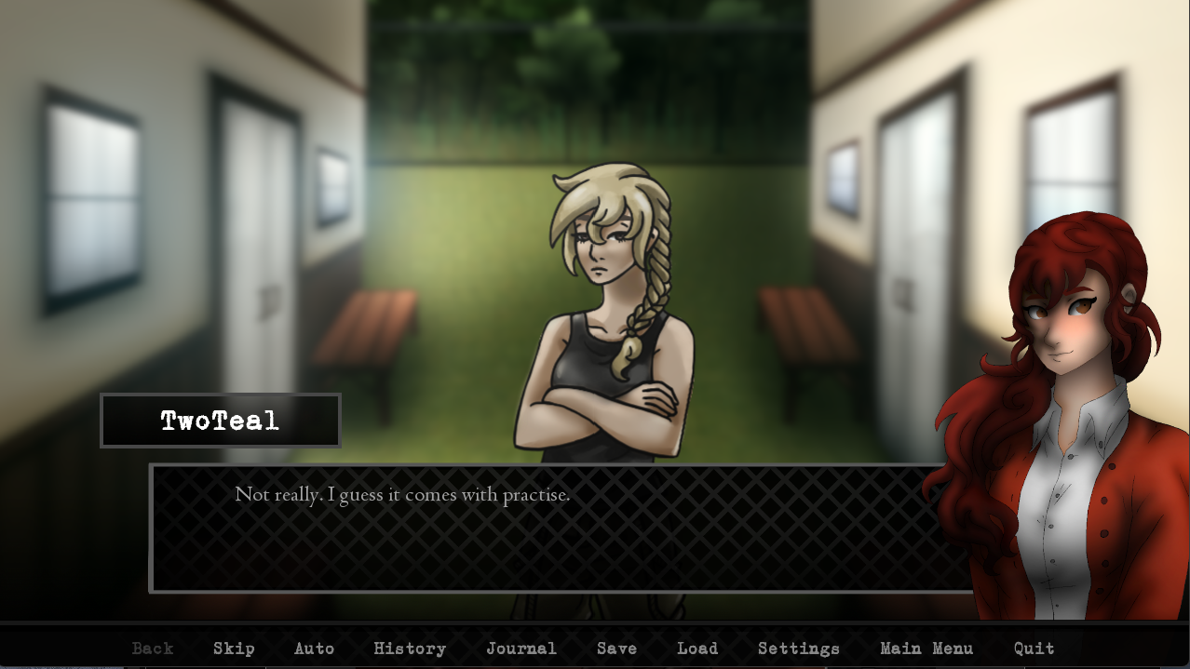

Practise is a word but a verb, while practice is the noun. I looked it up, it’s weird.

Second session, seeing Michael. Then I’ll start rotating between him, Charlie, and William for every second session. Tom still the first of course.

I need to remember; save at the end of day 2, once on page 5 slot 4, once on page 4 slot 4. This is to ensure I have at least one copy to start Michael testing with.

Interestingly, Tom’s sprite shows up on the box that says he enters and sits down. Michael’s sprite takes a screen before he enters and sits, only showing the chair at first.

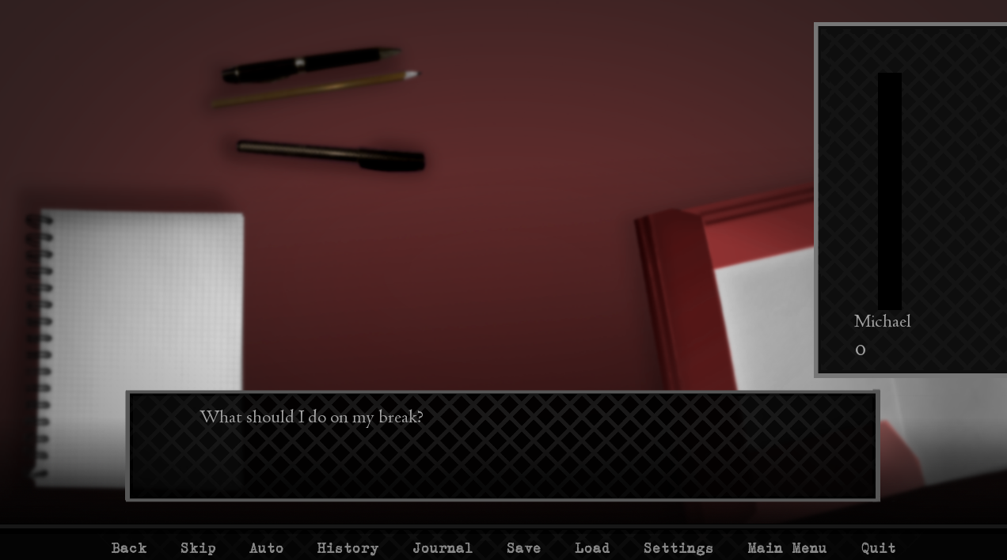

Oh first weird bug. It shouldn’t ask me what I should do on my break after asking “Are you into that?” with Michael. It could have something to do with me saving and reloading so much. I think it jumped track to get here.

Because I chose the other dialogue option before, and he went on about my pens not being aligned. That didn’t happen this time?

Had an unscheduled hangout with Sue during glitch day, time for the second Michael session in the same day

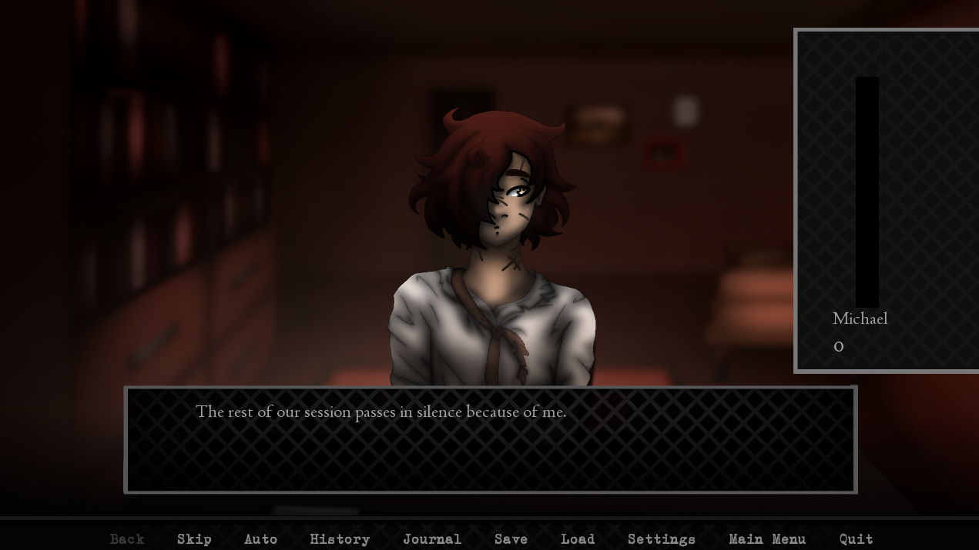

This is the screen it bugs out on, after that dialogue of “Are you into that?” Might rush through and see if anything else is different when it skips

Oh god, infinite Sue glitch. I’m on a different Sue event.

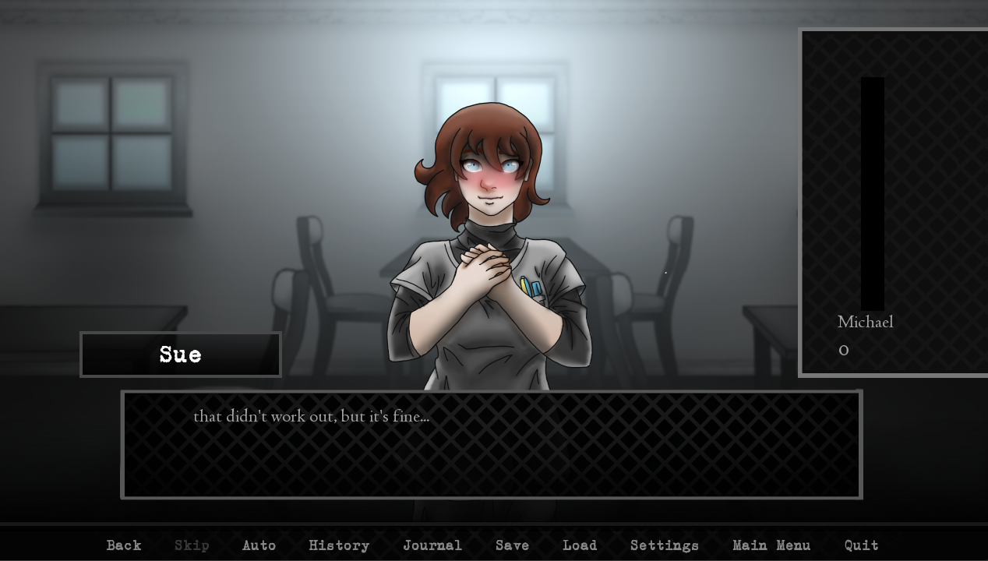

Lowercase sentence

Alright, infinite Sue glitch is fun but I get the feeling I’m going to break the rest of the game if I try to test in its current state. I’m going back to my untainted Michael dialogue testing save and picking the option I know will make the game normal again.

Day 3, saved at the start as I was supposed to. Tom first, then Charlie.

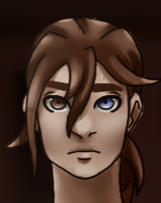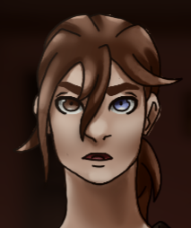These two sprites have slightly different arms at the bottom. Right shows skin from his arms, left doesn’t. I’m not sure if that’s acceptable, so I’m reporting it here.

Okay, session 1 day 3 done, Sue time again. But I already know how this should go I think.

Should meters be turned on for the Sue hangout? I’m not seeing any.

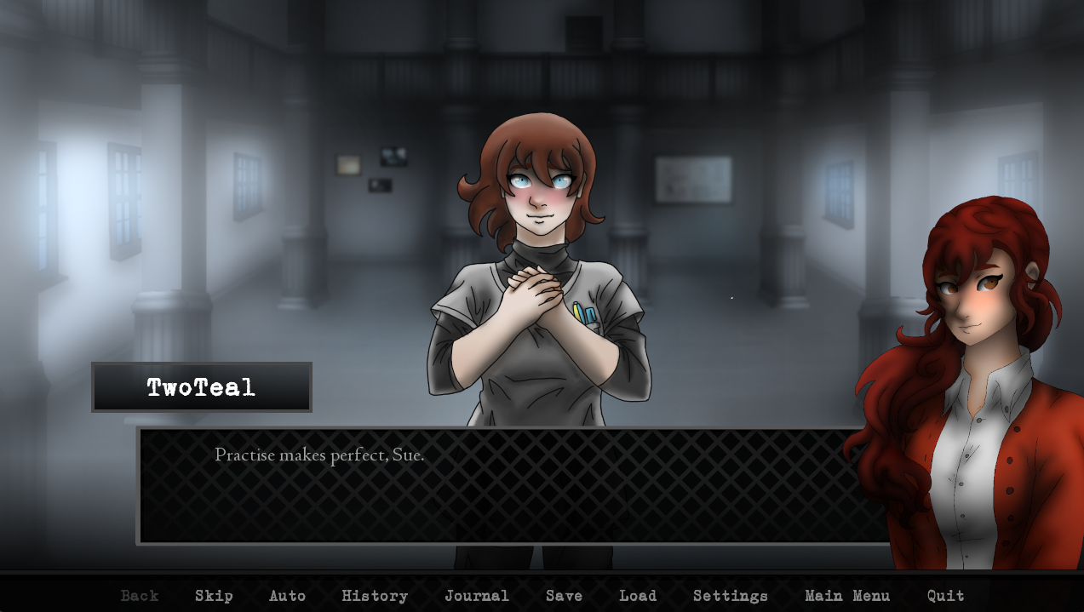

Practice on this screen too

About to see Charlie, but I won’t be testing him or William as thoroughly. If something does happen, I’ll still report it.

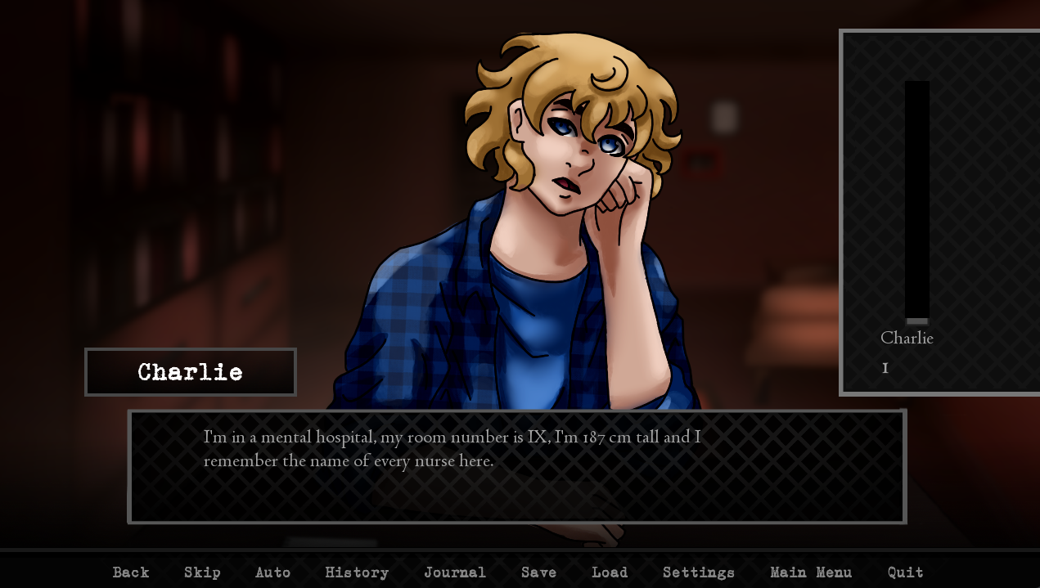

Oh yeah. If this is set in the US, metric system is kinda weird to use. He could still just be Quirky like that though.

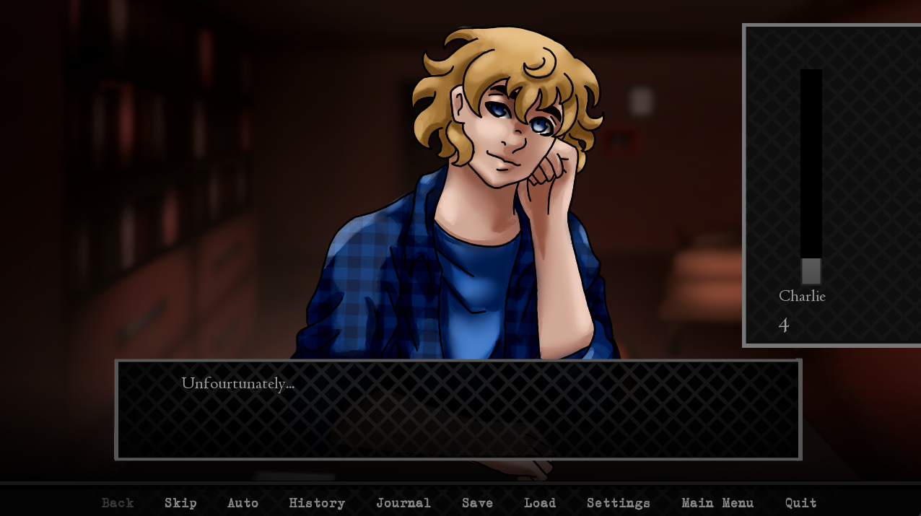

“Unfourtunately”

Day 4 – Tom then William

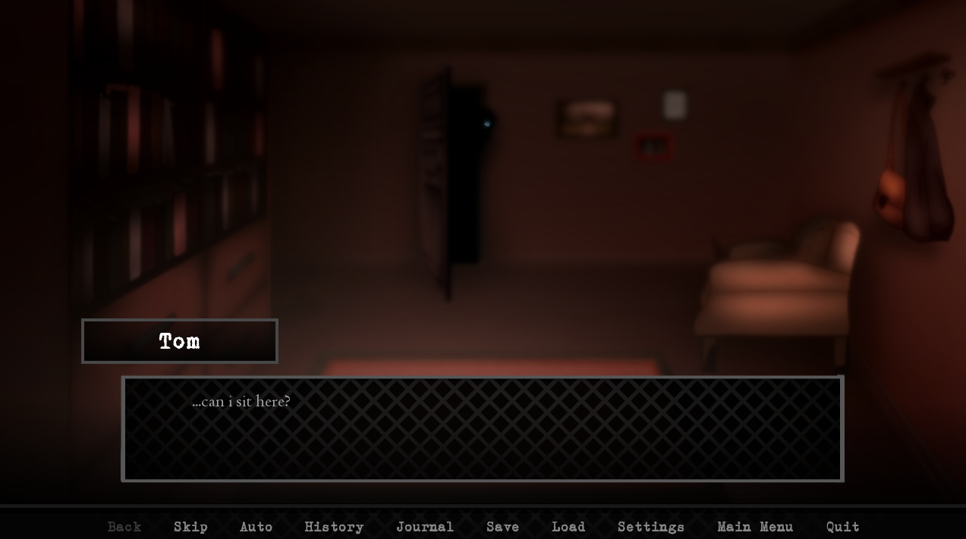

I think there was a chair visible in front of the desk in an older CG, but not this one

Wait, the chair is part of the sprite? The chair IS a sprite? Eh, maybe it’s not an issue.

Are Edward’s introduction text boxes meant to be lowercase?

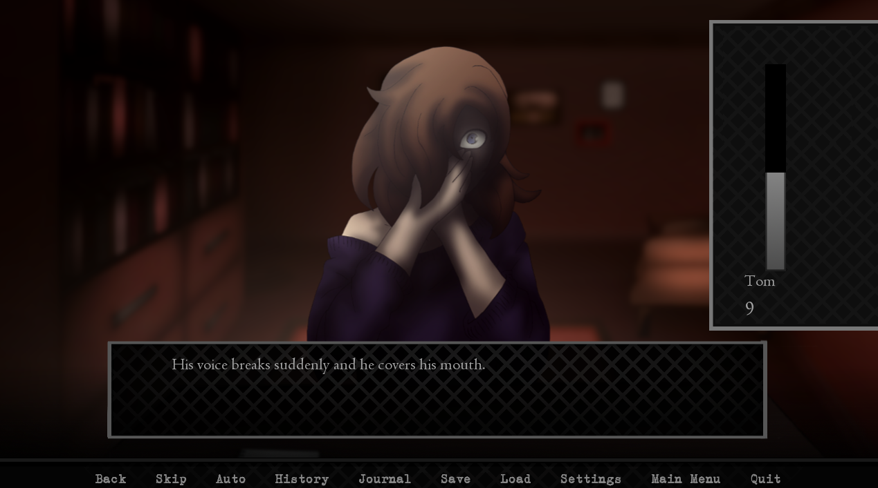

This looks like an older sprite

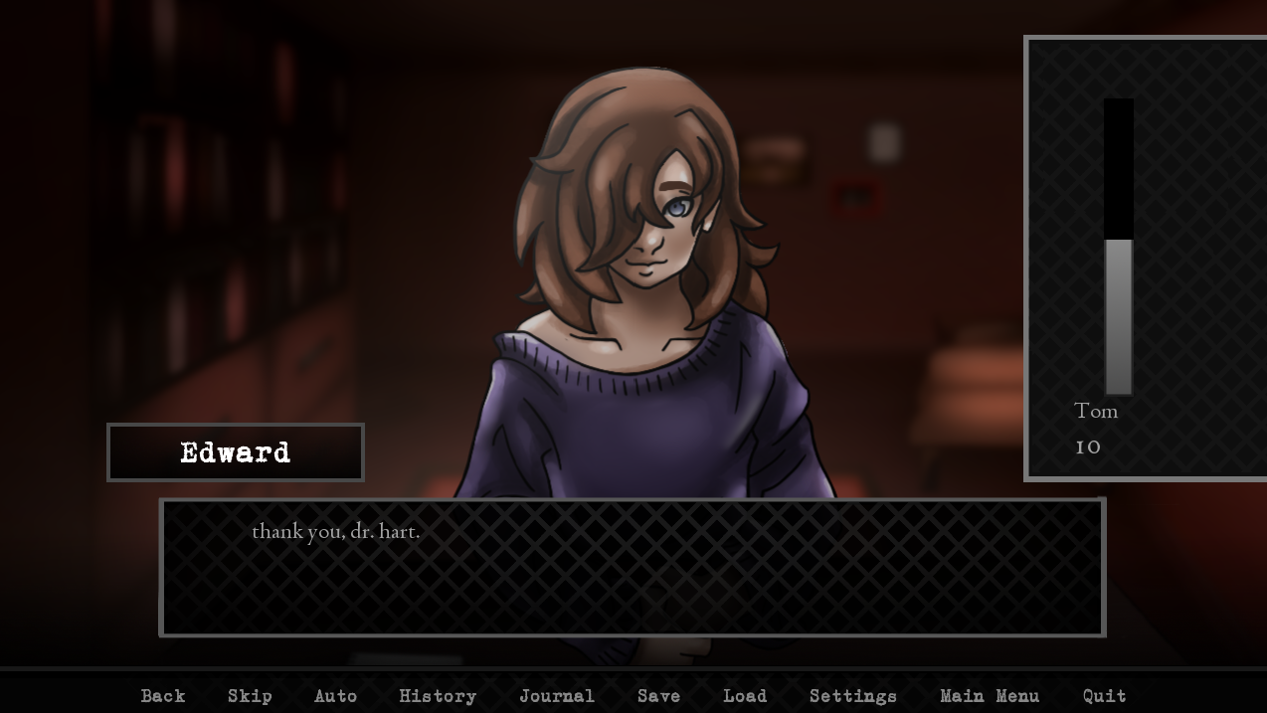

Versus this sprite, which looks newer

Break day 4 time for Sue, then Julia opens up as an option because I know too much

I already tested the first two Sue exploration events pretty thoroughly, so I’m not going as deep here.

William time

Normal day. No bugs that I can tell for Tom Week 1 Day 4.

Day 5 – Tom, Julia, Michael?

Kinda excited about finally seeing Julia

Saving in page 1 slot 6 just in case I mess up the day

Tom time

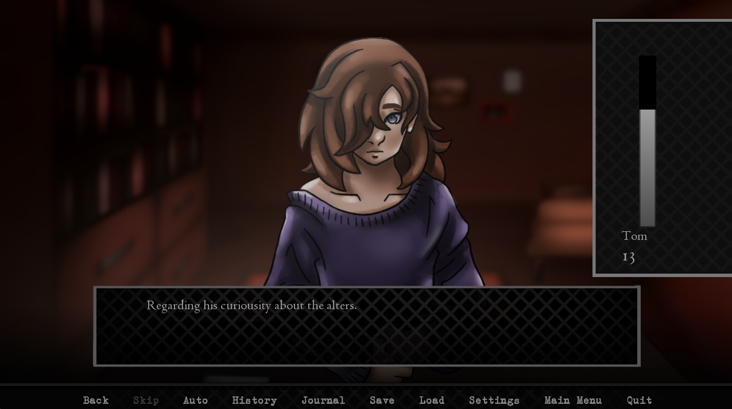

Curiousity should be curiosity

Nothing unusual. Time for Julia.

Nothing unusual, time for Michael.

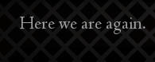 Hoping not to experience another Michael time loop here /j

Is Michael really supposed to be this hard to rank up? I’m only on 2 with him, 15 with Tom, 6 or 7 with the other two.

No Michael time loop this time, moving on to the interview.

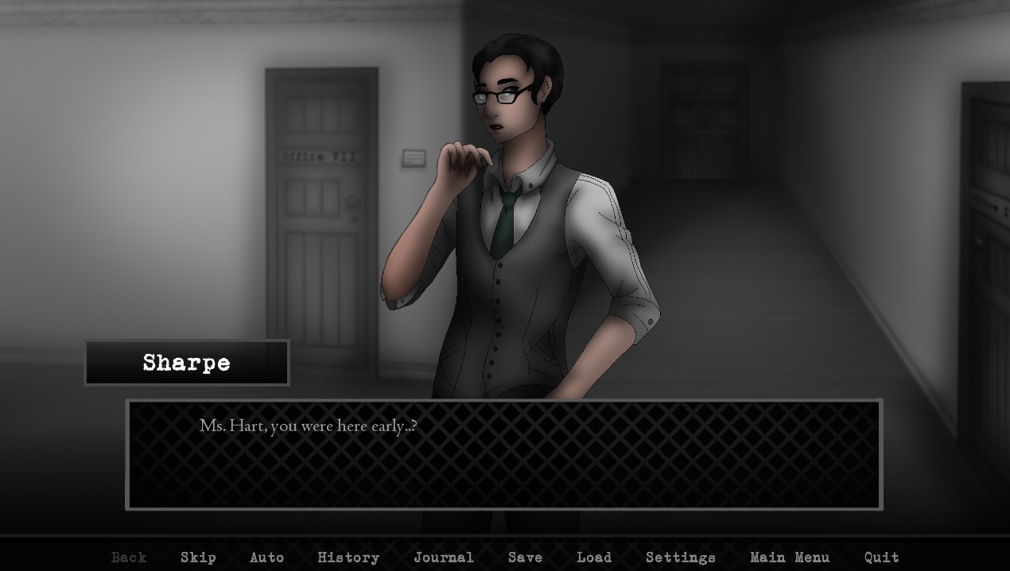

Should probably just be “you’re here early. The current phrasing sounds awkward.

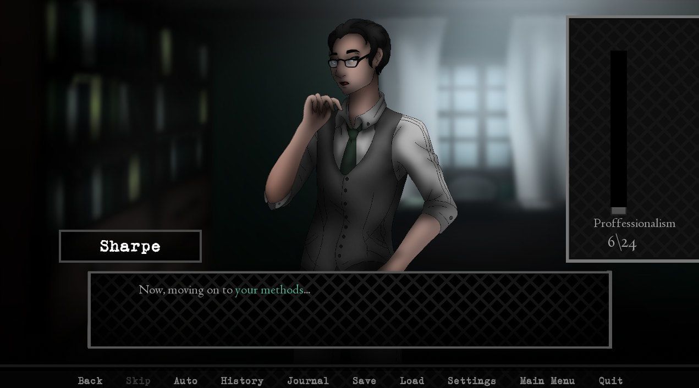

Proffessionalism again

After answering why I preferred Tom, this bug popped up. Dialogue options 1 and 1.

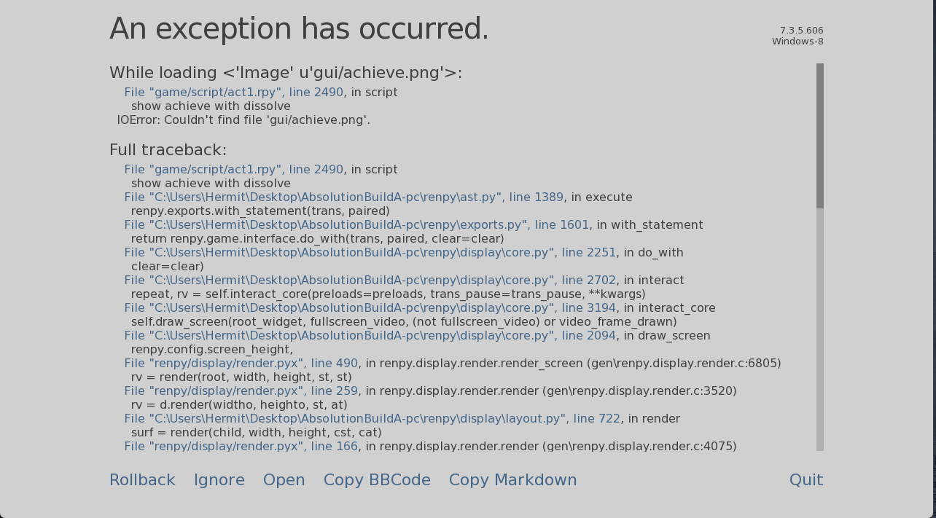

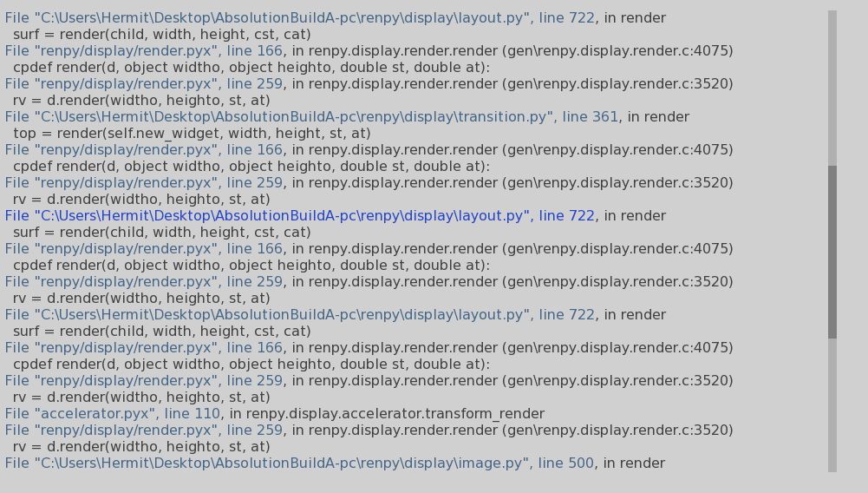

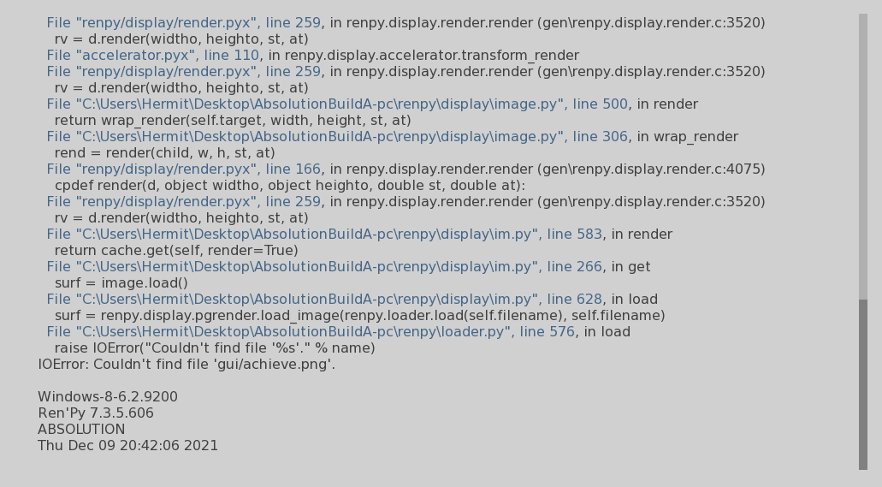

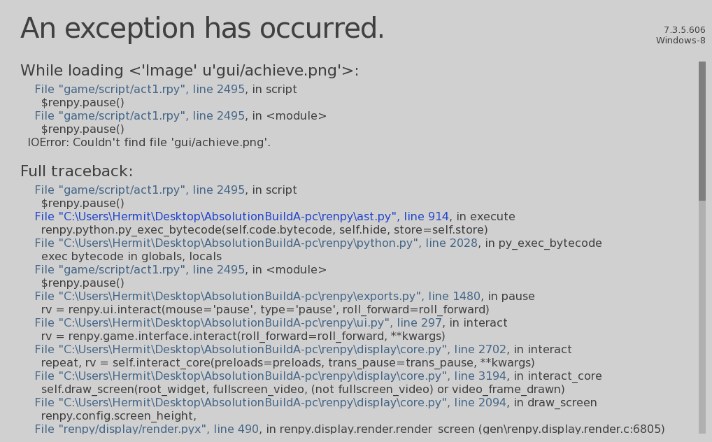

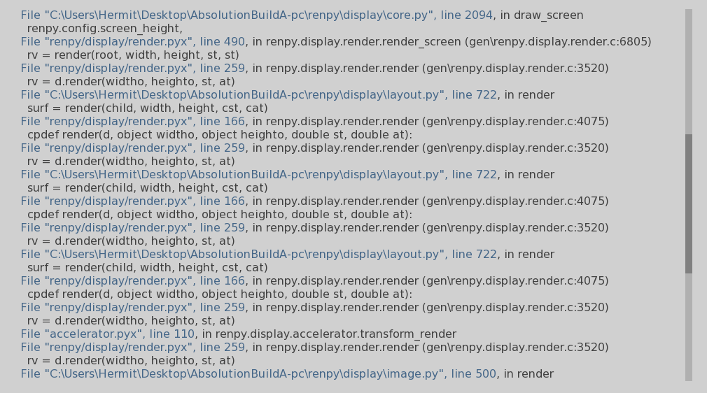

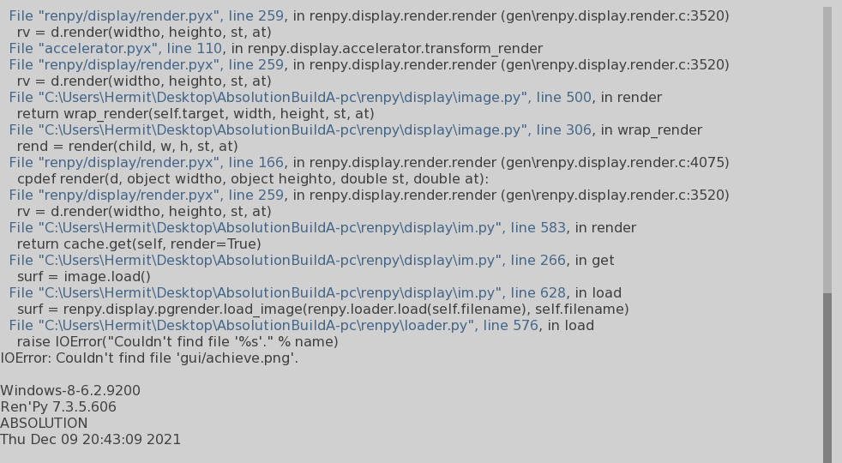

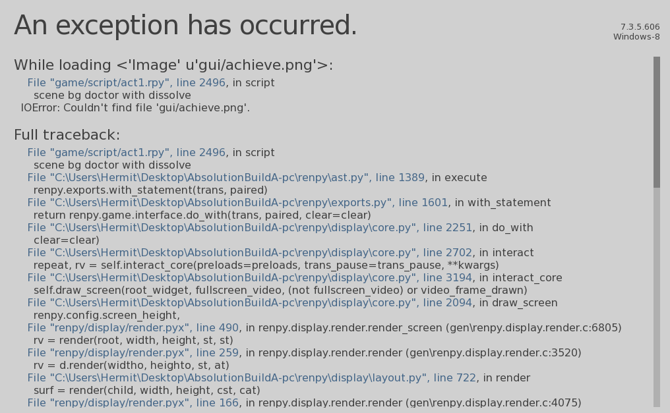

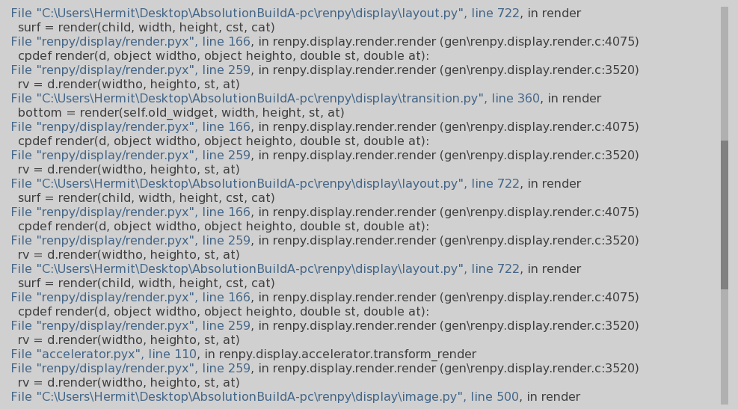

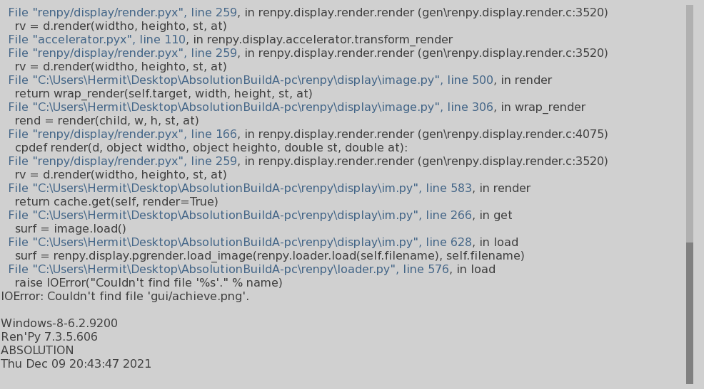

Leaving his office, this bug occurred

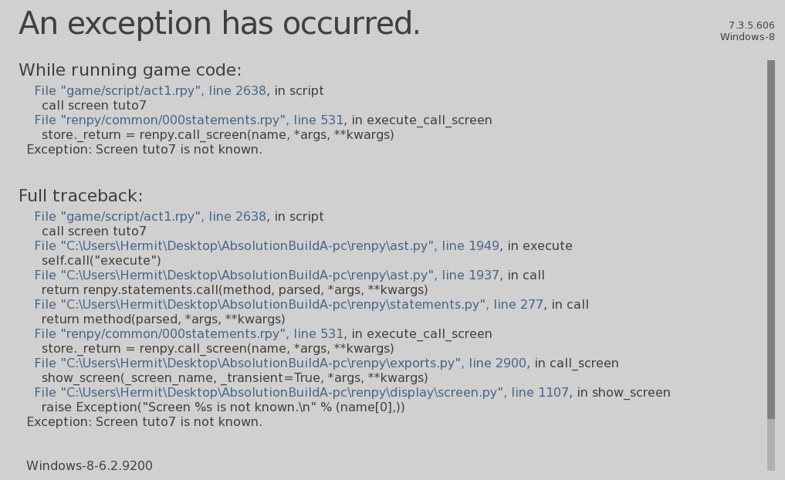

I went back to the final interview of week 1 to bug test the dialogue options

Here’s a typo I found

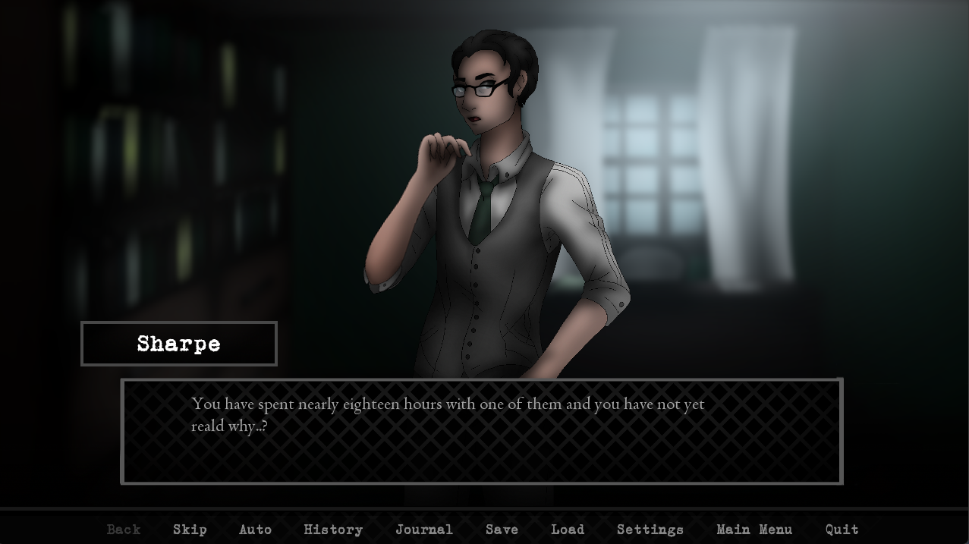

“Reald”

More bugs, yay. Here’s the screencaps for the exceptions.

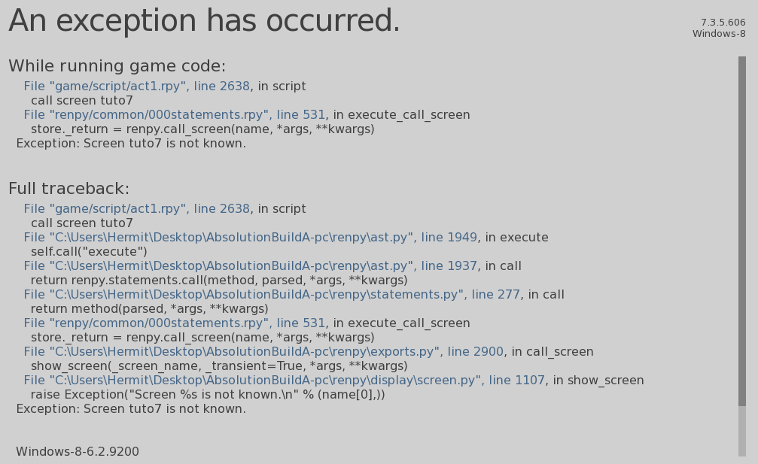

Also of note, the prompt to save the game doesn’t occur at the end of the work day if you say “I don’t know” to Sharpe like for the more professional answer

Woah, okay. Nevermind. Bad ending? That was depressing. Plus it’s impressive to see the game just quit itself like that.

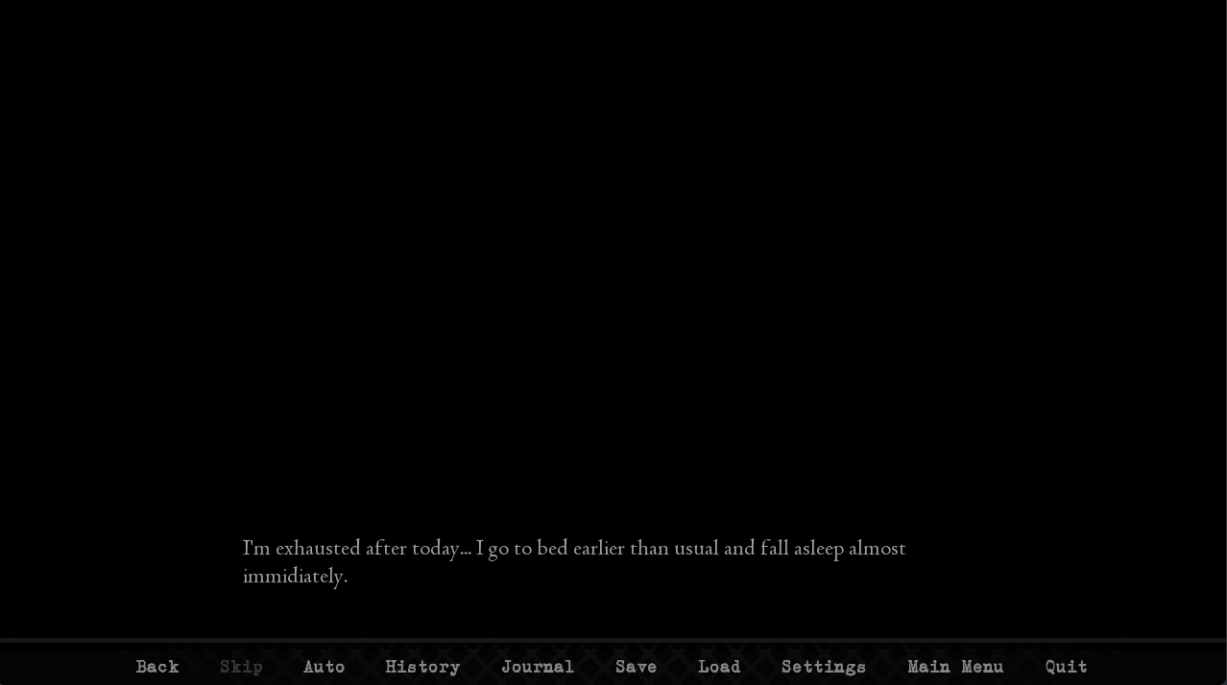

“Immidiately” should be “immediately”

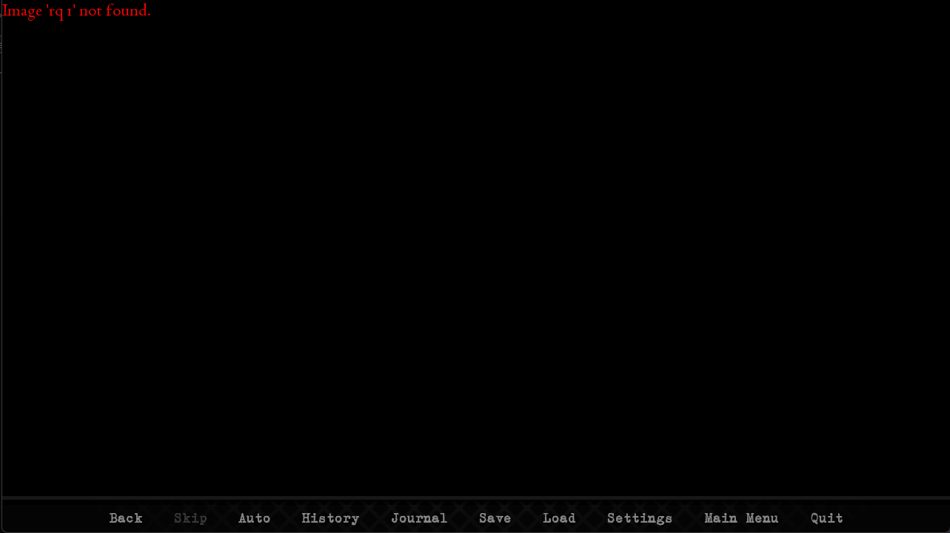

Dream sequence error

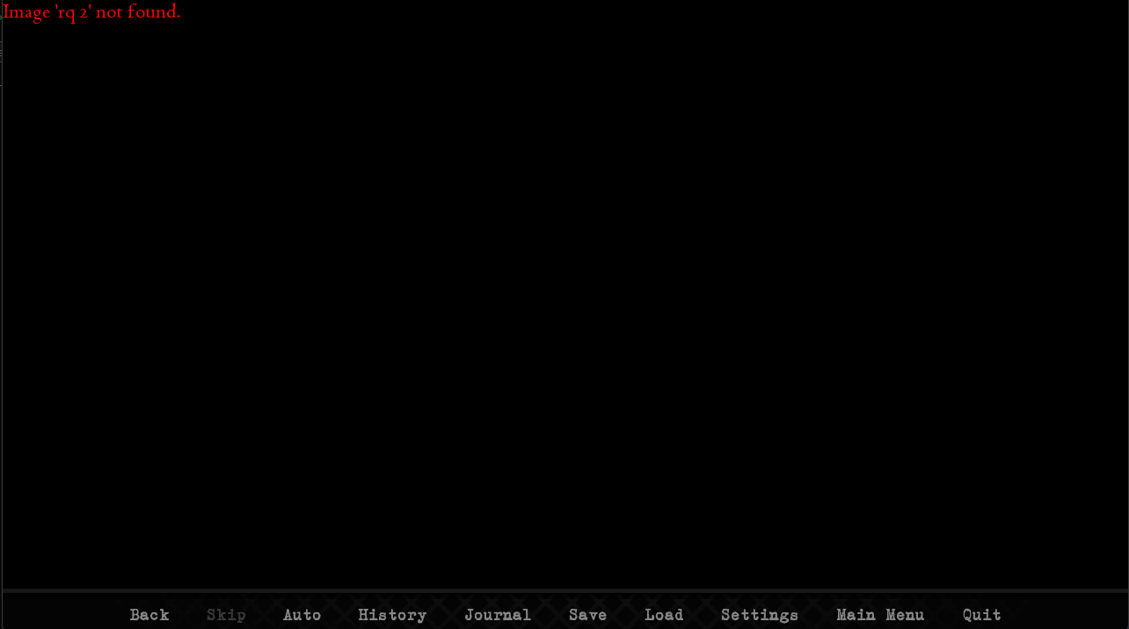**Another one, after entering room XV**

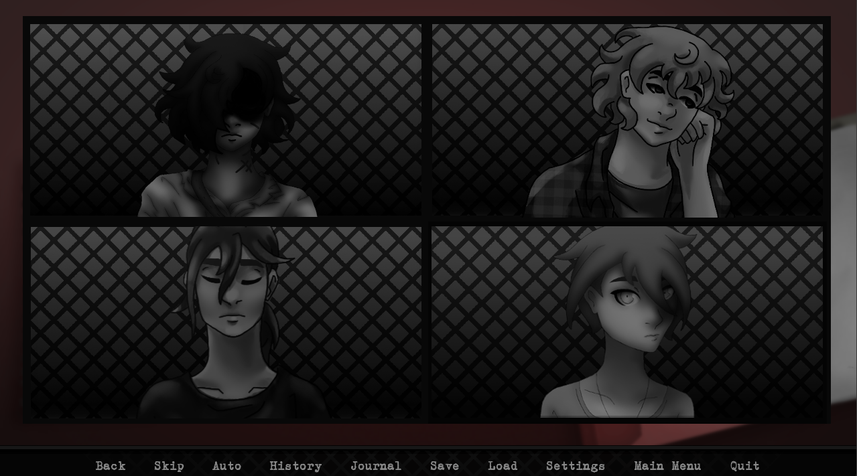

**The gore scene happened, then the next day intro screen played. I’m still given a choice over who to see first**

**For some reason going from the “statistics” screen back one takes me all the way back to the “rq 2 not found” error, and makes me rewatch the gore scene. Pretty unpleasant. And I think it tells me it’s November 6th, when it should be at least the 8th if Friday was the 5th.**

**Oh. There’s Weekend branching. I’ll need to ask you about that.**

**Still important to state, I went through the weekend like normal, no thorough testing, hung out with Julia then Sue, and Monday happened, still not automatically having the first session with Tom. It’s giving me generic text boxes like the weekend sessions did.**

**This must just be where everything goes off the rails or something story-wise. Now I’m having a dream sequence with Jane.**

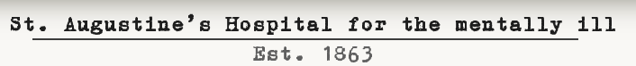

**“for the mentally ill,” is that a normal name for an asylum?**

**After the end of week 1, Elizabeth drops from the roster for break hangouts. I don’t know if that’s intended.**

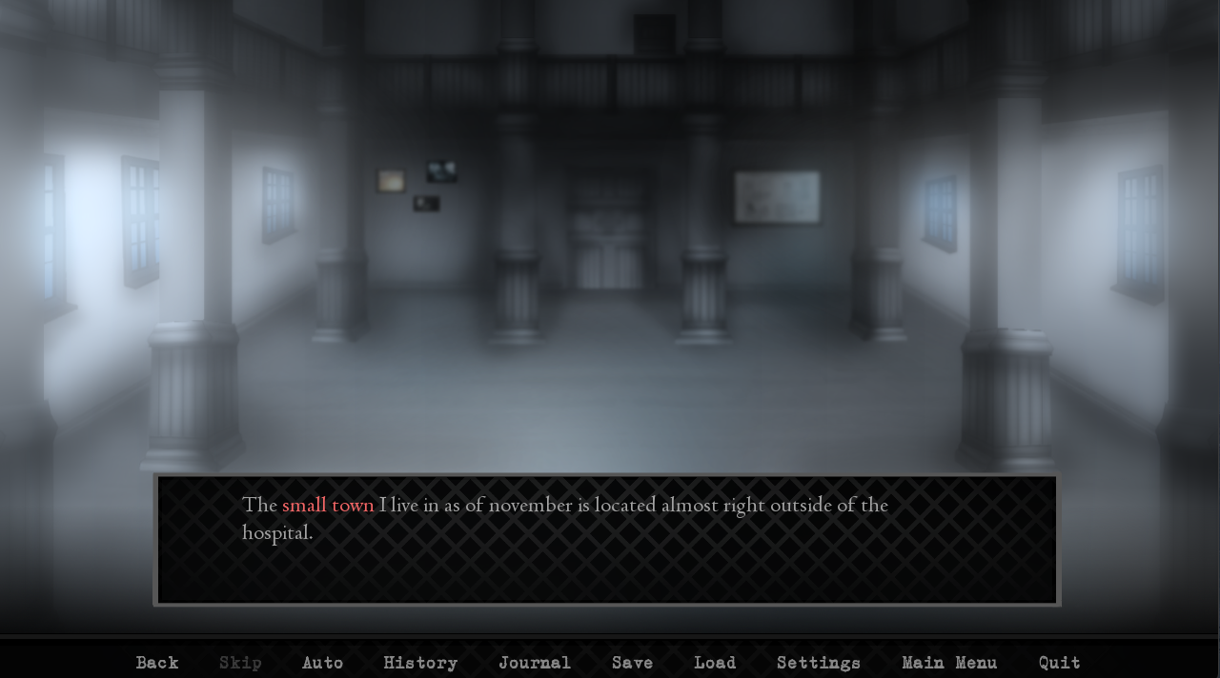

**One of the exploration events, second one, right after finding the map. November should be capitalized. Interesting bird sound effects :eyes:**

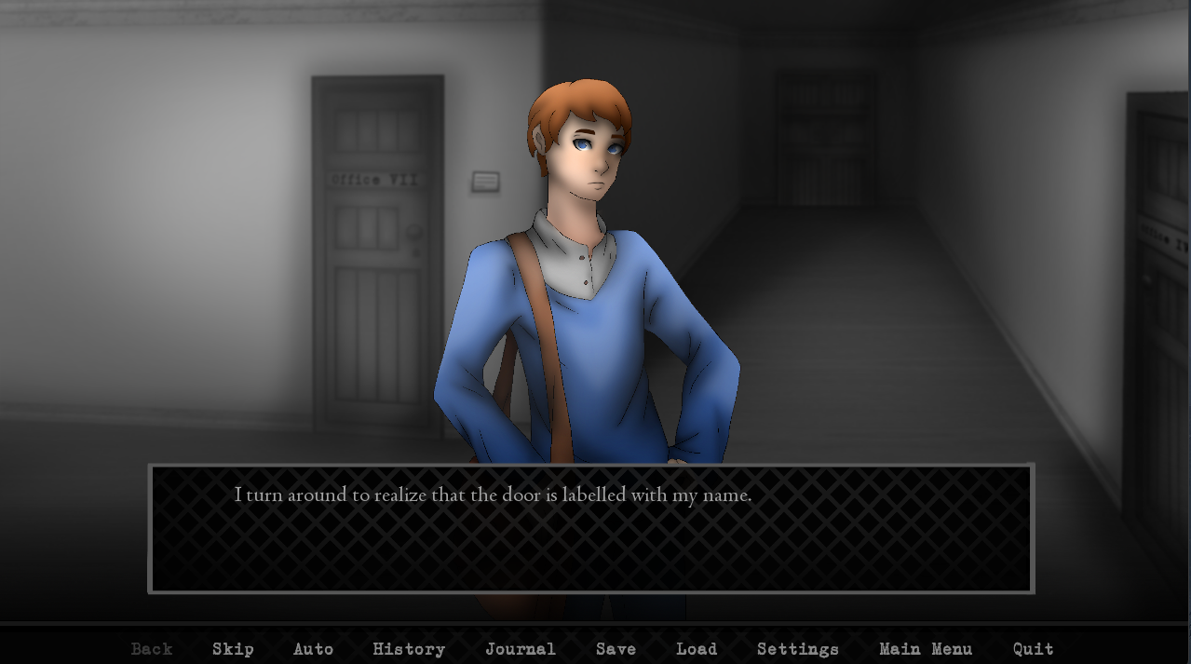

**This screen, “labelled” should be “labeled.” Though apparently Word doesn’t care about either spelling. Oh apparently “labelled” is the British spelling.**

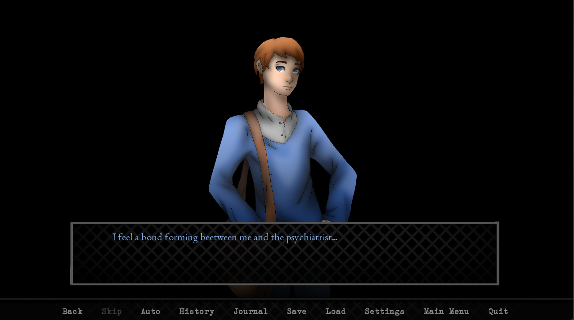

**Beetween instead of “between”**

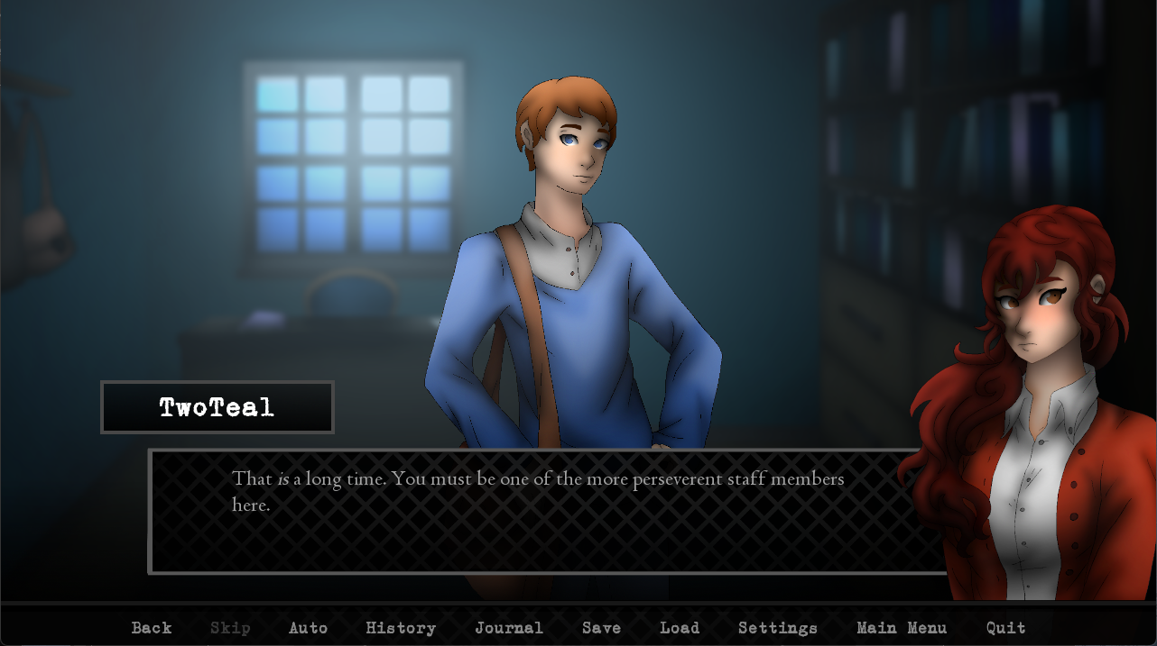**Dr. Young event 2, “perseverent” should be “perseverant”**

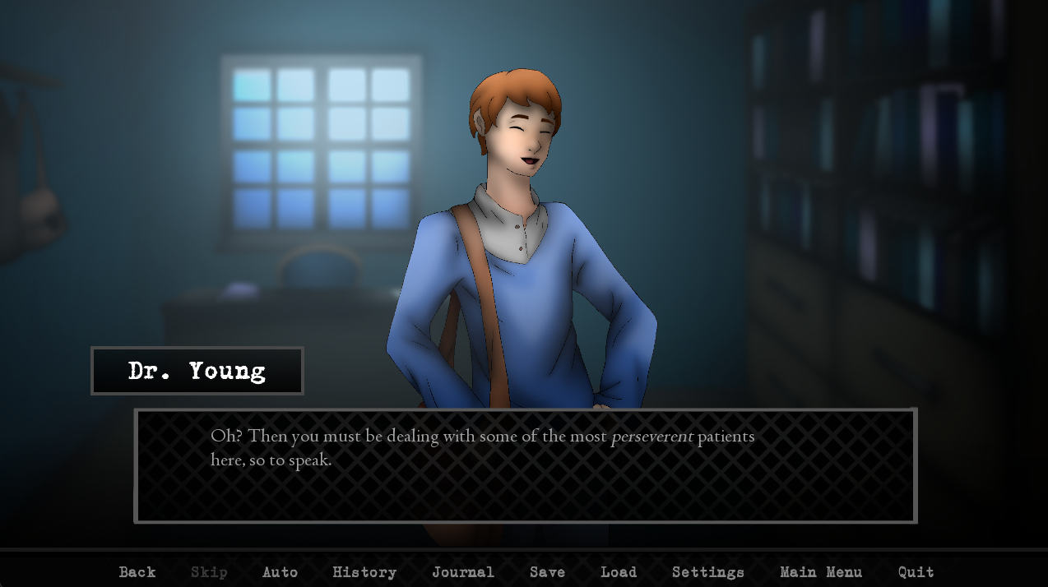

**Same here**

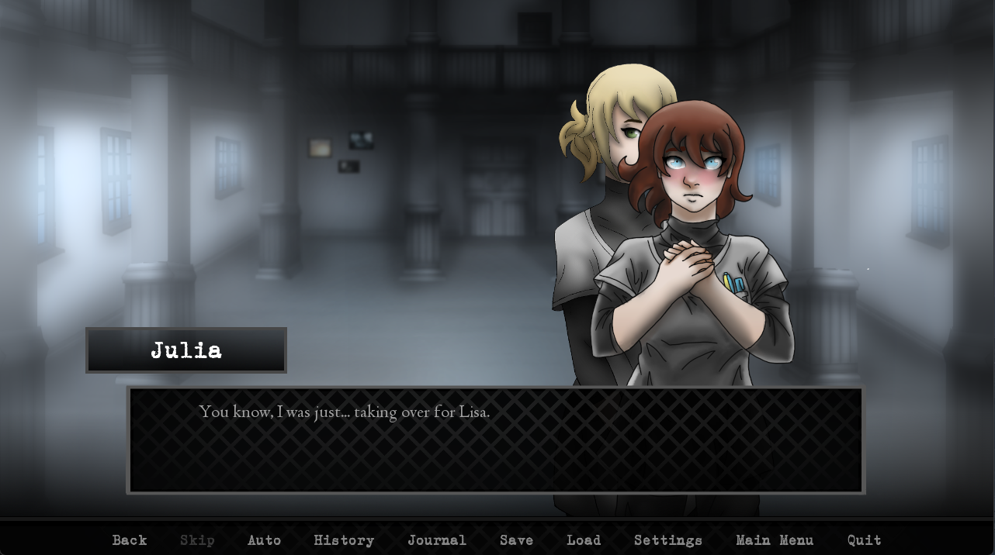

**This doesn’t look like it was intentional. Week 5 exploration event.**

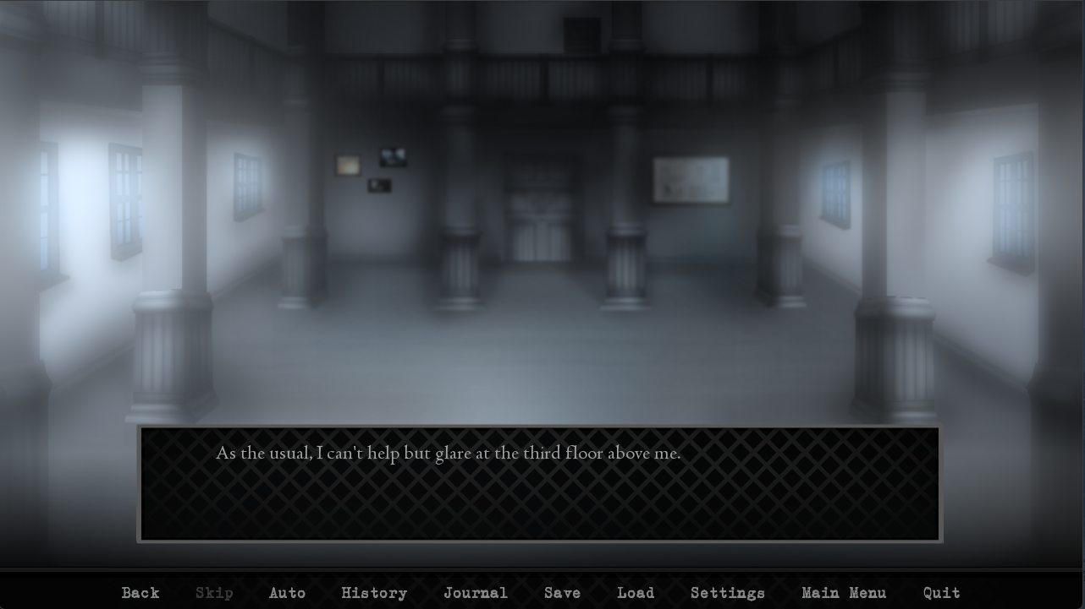

**Exploration week 5. “As per usual” would sound better.**

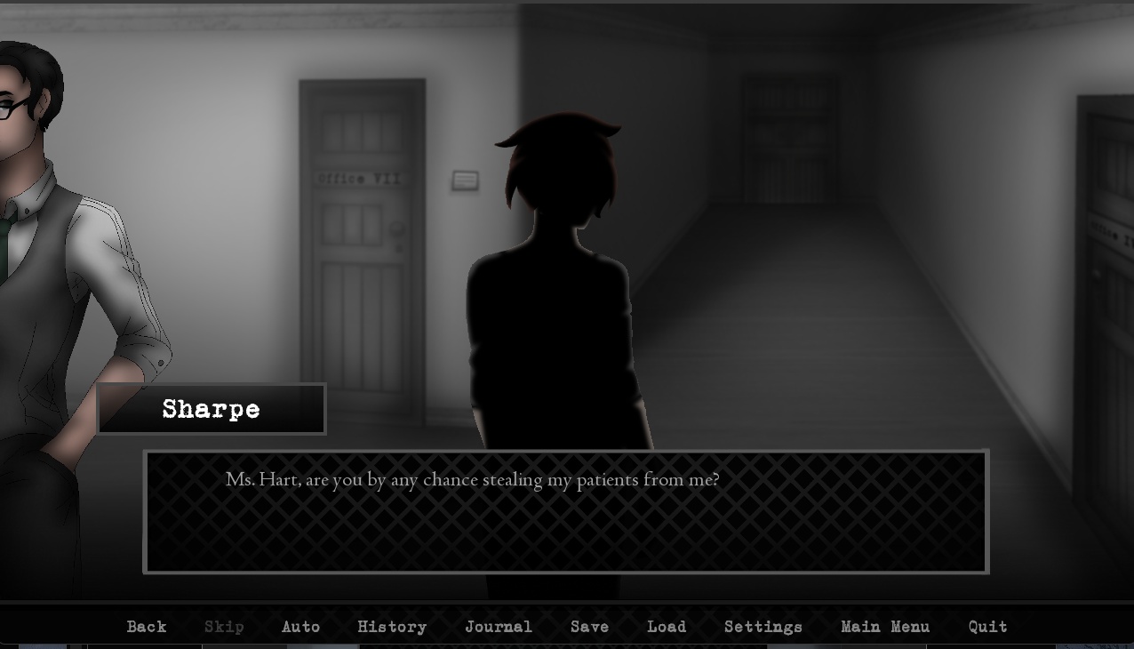

**Is Sharpe being this far off screen intentional?**

**Sunday week 5, I lose the option to stay in my office. Not that I used it but once this playthrough.**

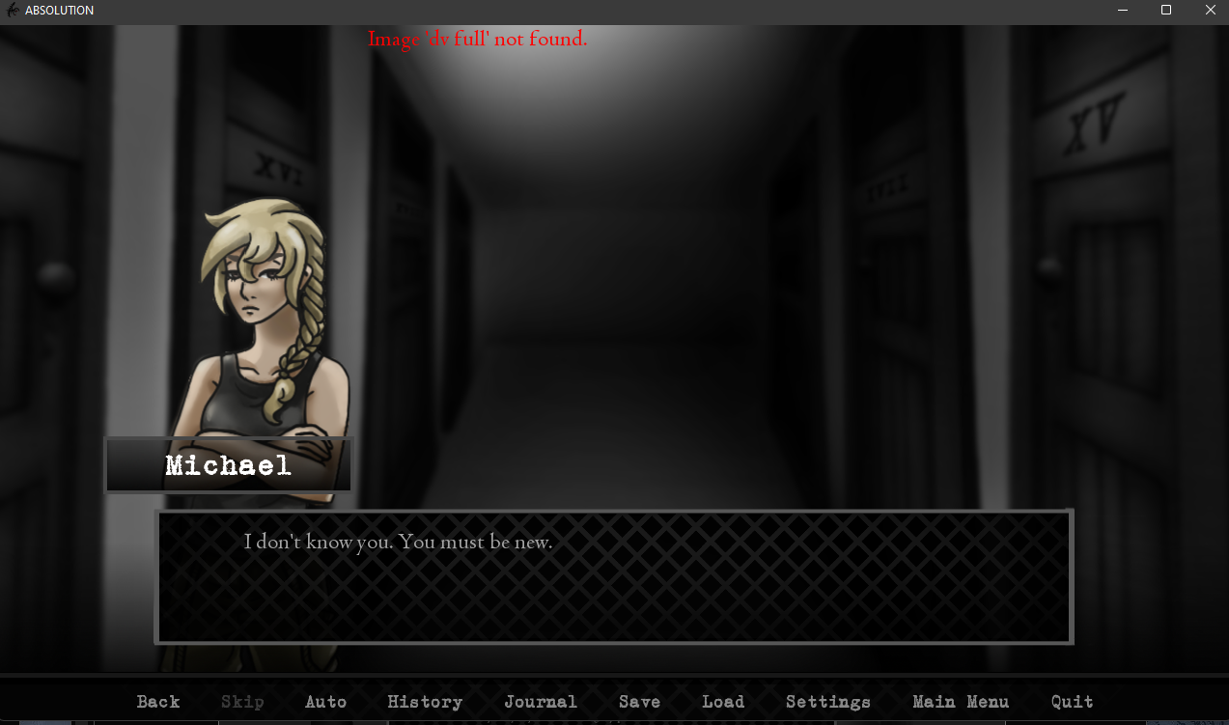

**Image error, so Michael didn’t load in I think**

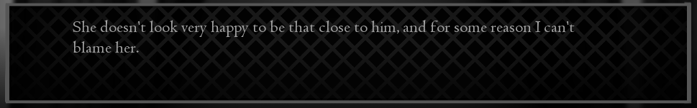

**Sue and Michael event week 6. “for some reason” should just be omitted. Hopefully by this point in the story it’s obvious why MC “can’t blame her”**

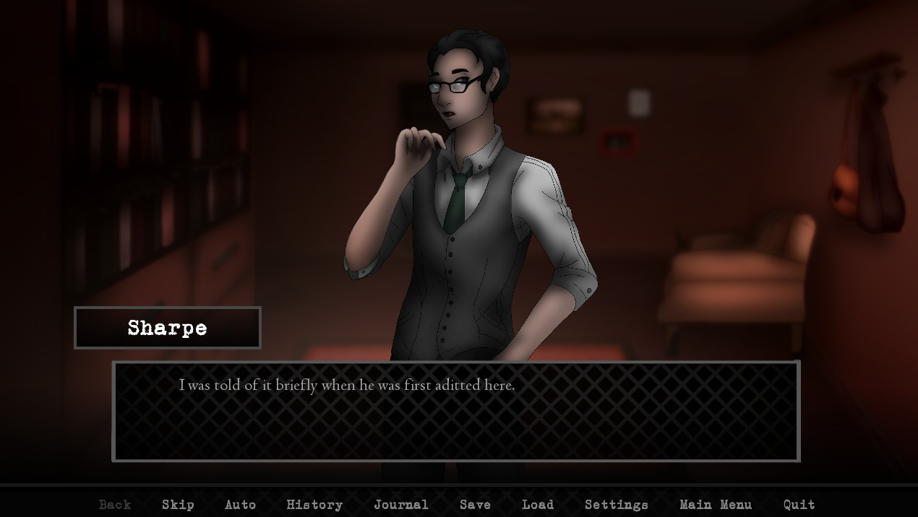

**Week 6 Sharpe conclusion I think? On Tom. “Aditted” should be “admitted”**

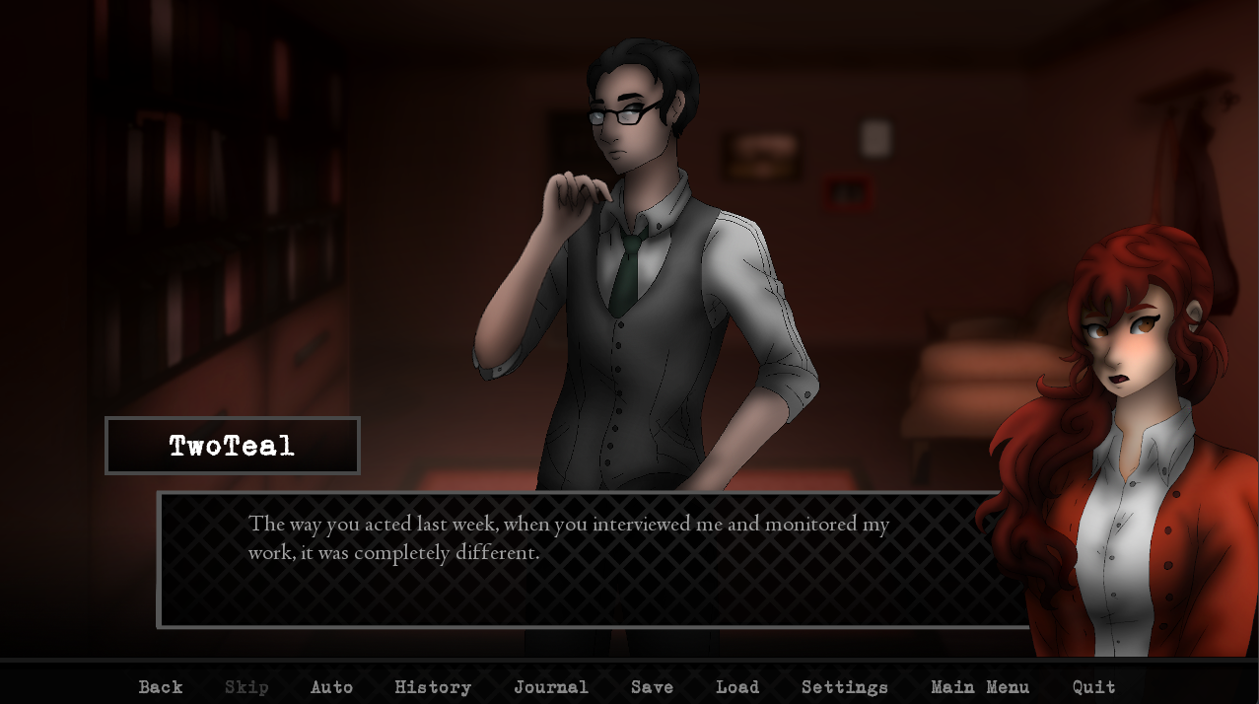

**This phrasing sounds like it should come a week after week 1, not in week 6?**

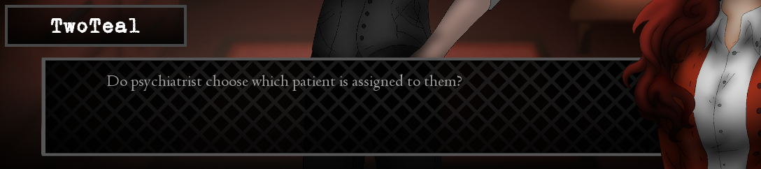

**Grammar error when asking about the other psychiatrists, a few screens in. It should either be “do psychiatrists” or “does a psychiatrist”**

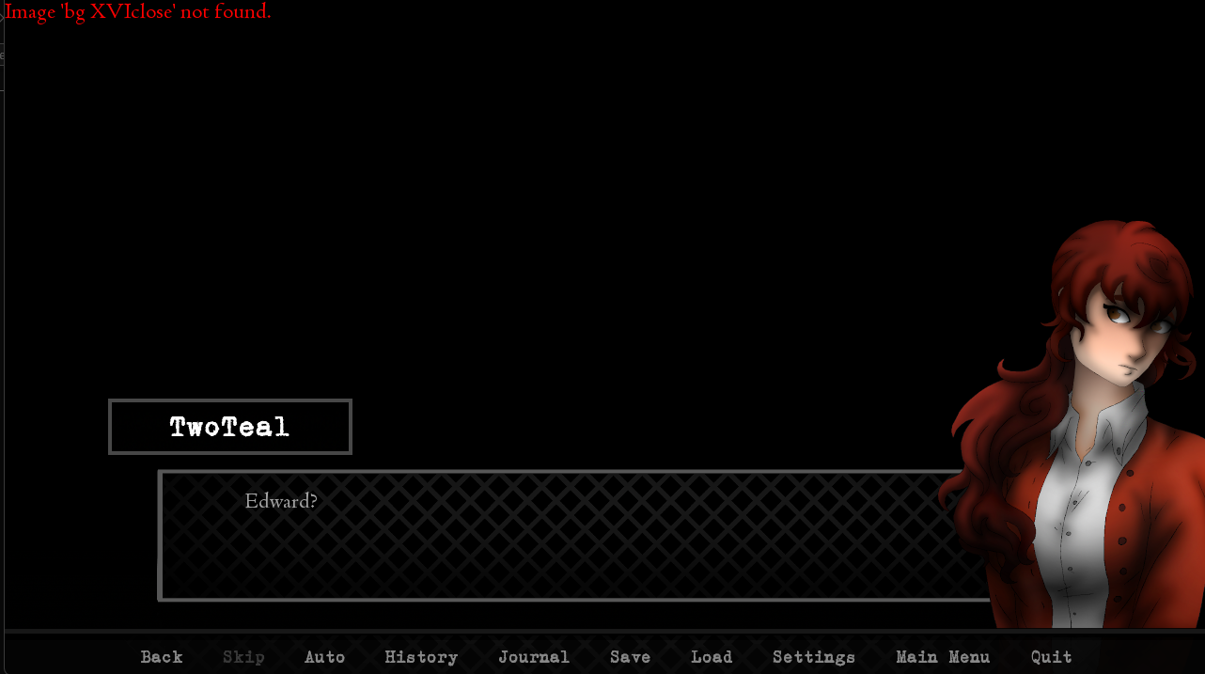

**Another image load error on looking in Tom’s cell**

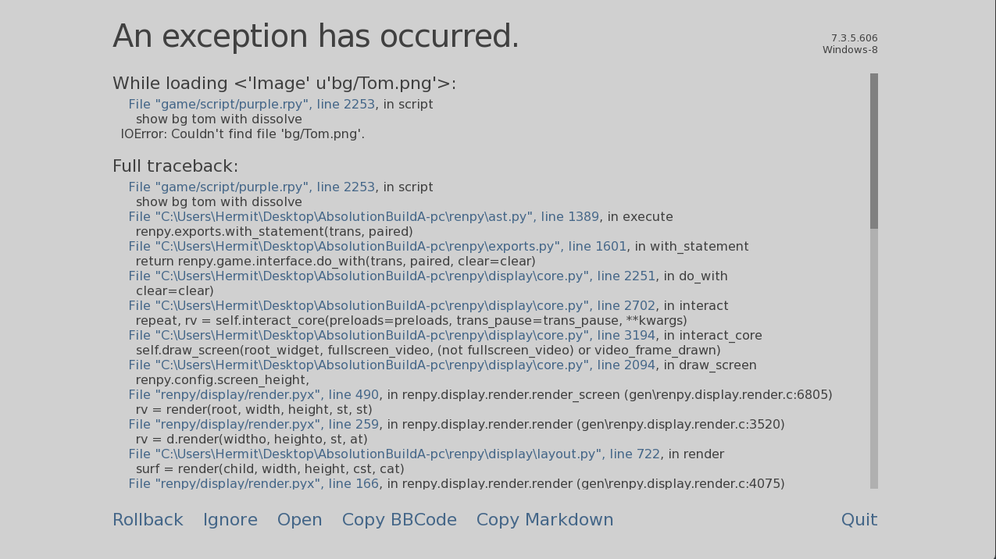

**Right after the last screen I capped, this error**

**After that each text box shows up as an exception, so I assume this just isn’t finished**

**I ran the course of a bunch of different days until December 30, a bunch of exploration and social events, then went back to a previous gamesave at the end of week 2 to confirm if week 2 was broken, and it seems to be no matter what option I pick.**

**Saturday/Sunday autoplays and gives me generic messages for therapy sessions. Monday continues the same way. I’m not clearly “locked in” to Tom’s route despite Sharpe confirming that I was at the end of week 1.**